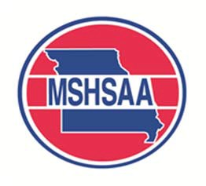
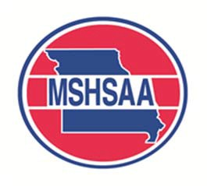
MSHSAA Affiliate Media Partner Program
Registration Form

For outlets wishing to pay rights fees for the entire academic year, there is the Affiliate Media Partner Program. For $200 an entity could produce an audio only broadcast of any MSHSAA post-season event. For $300 an entity could produce a video broadcast of any MSHSAA post- season event that is not covered by the MSHSAA production company.
The entity would still be responsible for filling out the appropriate broadcast agreement for and filing it with the site manager for the specific contest. The entity will still be responsible for a sponsor list, as well as a memo from the MSHSAA office stating its membership in the affiliate program.
The fee must be paid by Tuesday, October 3, 2017 in order for the outlet to be considered part of the affiliate program for the fall sports season and the remainder of the academic year. If your outlet wishes to pay via credit card please contact the MSHSAA office.
A second deadline of Friday, February 9, 2018 will be for outlets wishing to participate in the program for winter and spring sports. The fee remains $200 for audio and $300 for video broadcasts.
Once the appropriate deadline has passed, no outlets will be granted "Affiliate" status. For example, an outlet calling on Oct. 5th will not be granted affiliate status for the fall sports. Contests will be billed at the appropriate per-game rate. The same outlet may apply for affiliate status during the winter and spring sports seasons.

Outlet Information
Outlet Name: (call letters)
Federal ID #:
Contact Information
Contact Name:
Office Phone:
Cell Phone:
E-Mail Address:
Billing Information
Billing Contact Name:
Office Phone:
Billing Address:
E-Mail Address:

Return form with payment to: MSHSAA (Attn: Jason West, Communications Director), 1 N. Keene St., Columbia, MO 65201

