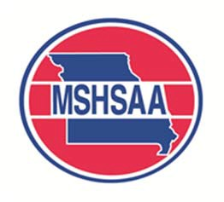
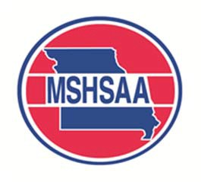

MSHSAA Affiliate Media Partner Program
2021-22 Registration Form

2021-22 Pricing for Academic Year
Audio-only broadcasts:  Webstreaming Video broadcasts:  Television Only broadcasts: | $200  $0*  $500
For outlets wishing to pay rights fees for the entire academic year, there is the Affiliate Media Partner Program. For $200 an entity could produce an audio only broadcast of any MSHSAA post-season event. For $500 an entity could produce a Television only broadcast of any MSHSAA post- season event that is not covered by the MSHSAA production company.
All streaming video broadcasts must be held on the MSHSAA.tv platform. These broadcasts will be behind a paywall. Producers will receive 20% of the pay-per-view revenue generated by the broadcast. Producers of streaming content will not have to pay a rights fee for post-season contests streamed on MSHSAA.tv.
The entity would still be responsible for filling out the appropriate broadcast agreement for and filing it with the site manager for the specific contest. The entity will still be responsible for a sponsor list, as well as a memo from the MSHSAA office stating its membership in the affiliate program.
Arrangements for payment of any applicable fees or membership in the AMP program must be made prior to any productions of post-season content. If your outlet wishes to pay via credit card please contact the MSHSAA office.
A final deadline of Friday, February 11, 2022 will be for outlets wishing to participate in the program for winter and spring sports. Once the deadline has passed, no outlets will be granted "Affiliate" status.

Outlet Information
Outlet Name: (call letters)
Federal ID #:
Contact Information
Contact Name:
Office Phone:
Cell Phone:
E-Mail Address:
Billing Information
Billing Contact Name:
Office Phone:
Billing Address:
E-Mail Address:

Return form with payment to: MSHSAA (Attn: Jason West, Communications Director), 1 N. Keene St., Columbia, MO 65201

