MSHSAA District Solo/Small Ensemble
Festival Entry Instructions

General Information
You must have registered as a user with the MSHSAA Festival Manager program and updated your profile before you will be allowed to enter ANY festival. To update your profile, log in to the MSHSAA Festival Manager Program and follow the directions on the opening page. It will prompt you to add the proper school to your profile and ask for names of your students and accompanist. You only need to list the names of the students who are performing in solos or small ensembles. If you are taking only large groups to festival you do not need to list any individual student names, unless the festival is combined with the solo and small ensemble events being held on the same day. In this case you would only list the student(s) that are taking a solo/small ensemble event.

Next, check to see if your accompanist is listed. If not, please add their name and city where they reside, the program will not 'double-book' your accompanist, even if they play for many different schools during your festival as long as all schools agree on the spelling of the accompanists name (i.e. Patricia Smith, versus, Patty Smith, versus Pat Smith). The program would consider this to be 3 different individuals and therefore double-book the accompanist. Again please include the city where the accompanist resides. This should easily identify accompanist's that may share the same name and allow you to select the correct accompanist.

An accompanist may register as a user with the Festival Manager program to access a copy of their schedule. In order for this option to work you must use the accompanist's correct name.

DO NOT list an accompanist as 'Eagles1' or 'Rushmore HS'. The accompanist will not be able to access their complete schedule if the names do not match and the false name will be removed from the accompanist list immediately.

REMINDER: Please use proper format when entering all participants. Avoid using all upper or lower case letters.

Be sure the 'pop-up' blockers are turned off. To test for this, click the 'Help' button at the top of the page, you will find a test for pop-up suppression here. If you do not turn this off, you will not be able to see all entry pages, or view the PML (Prescribed Music List).

Before you begin entering events you will need to confirm that your school roster is updated and the information appears correctly in the Festival Manager program. Information on how to update the roster is listed below.

How to Update School Roster
Select the ‘School Roster’ link on the gray toolbar after you log in (see green arrow, Figure 1).

Figure 1
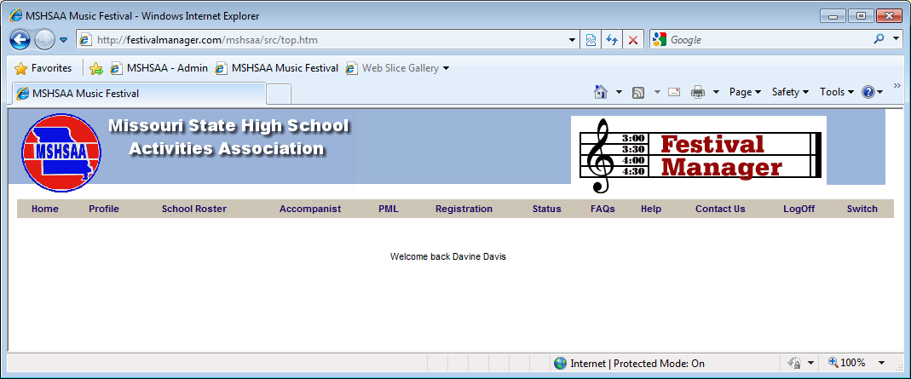

This is where you will add and remove students on the roster. To add students select the link ‘create a new student’ (see red arrow, Figure 2). A new screen will appear (Figure 3). Any field appearing in red is required information. Enter the student’s last name then first name. If you receive a message that the student’s name already appears in the Festival Manager program you will need to do one of two things. First, check to see if the student has moved to your district from another district. If so you will need to contact the school and ask that director to remove the student from their roster. This should allow you to enter the student. Second, the student may have the same name. You will need to add a middle initial or make the name unique to the program (i.e. John P Smith or John Smith (Mexico)). Next enter the grade level for the student. If you have any problems please contact the MSHSAA office. Once the information has been entered click the ‘Create’ button and ‘OK’. The name should now appear in alphabetical order on your roster.

To remove students place a check in the box beside the name(s) and select the link ‘remove checked student(s)’ (Figure 4). You can select multiple names to remove at one time. To edit or update any information regarding students appearing on your roster simply click on the name of the student. Remember to select the ‘Save’ button when you are finished or the information will not be updated.

NOTE: Grade levels are adjusted upwards when a new festival year is initiated. Once the grade level reaches 13, the student is automatically removed from the School Roster.

Figure 2
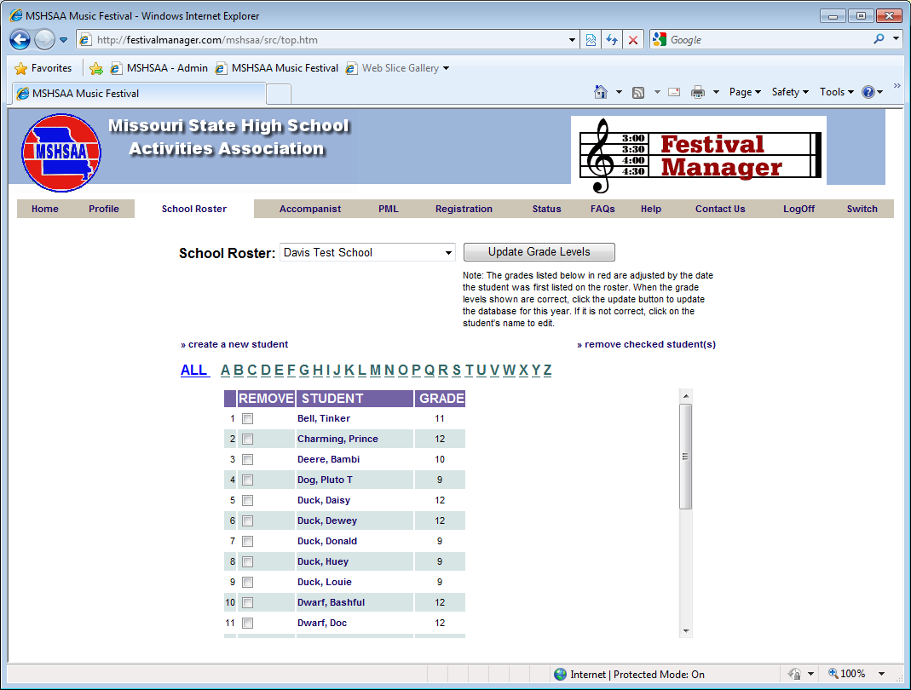

Figure 3
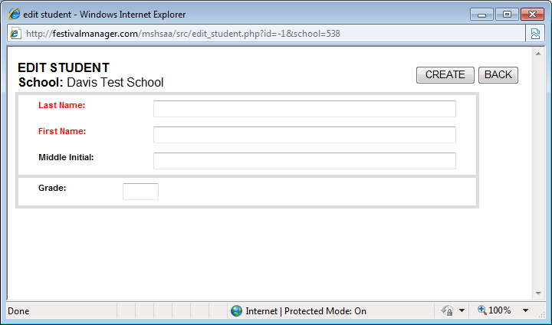

Figure 4
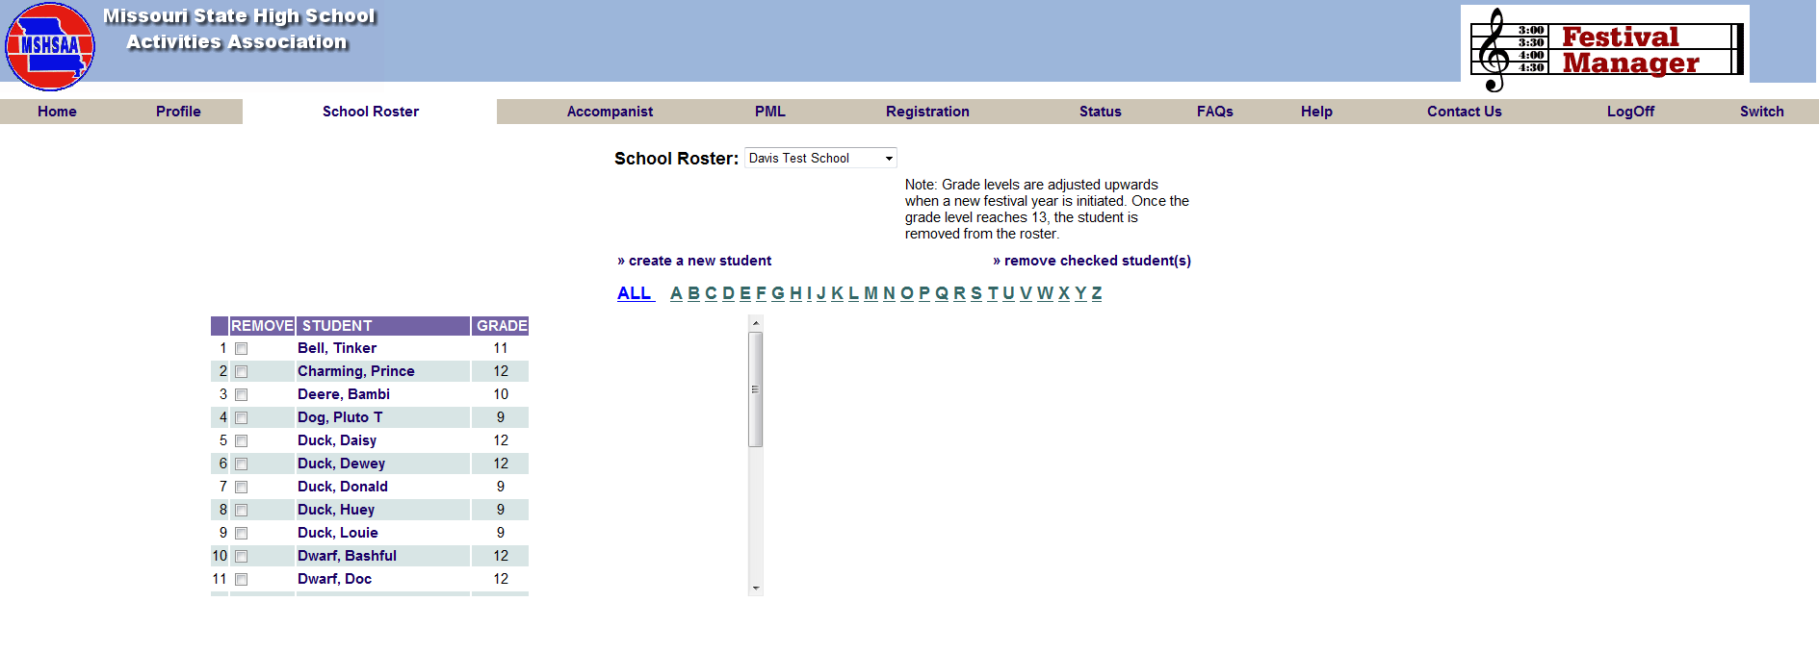

How to Enter a Solo or Small Ensemble
After you log into the MSHSAA Festival Manger, click on the 'Registration' button located on the gray toolbar at the top of the page (see blue arrow, Figure 5). You can use the 'Filters' (see double yellow arrows, Figure 6) at the top of the page to display a particular district, type or instrumental type of festival. Before you select your festival please click the 'Details' link (see red arrow, Figure 6) located on the left hand side of the screen (under the Name Column). If the festival name appears in gray the window has not opened and the entry process cannot begin. The window to submit entries will open 2 weeks prior to your district entry deadline. To see when the window will open place your mouse pointer over the name of your festival and click. A pop-up window will appear with this information.

A list of 2015 festival dates and deadlines is available on the MSHSAA website under the 'music activities' link. You can also click on the name of the manager of the festival and an email window will appear if you have a specific question that you want to send to your festival manager.

Figure 5
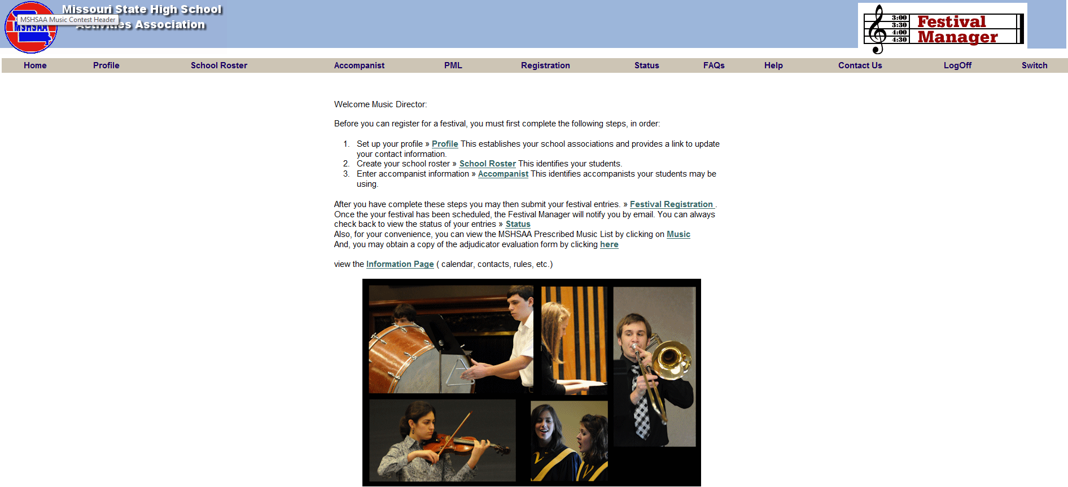

Figure 6

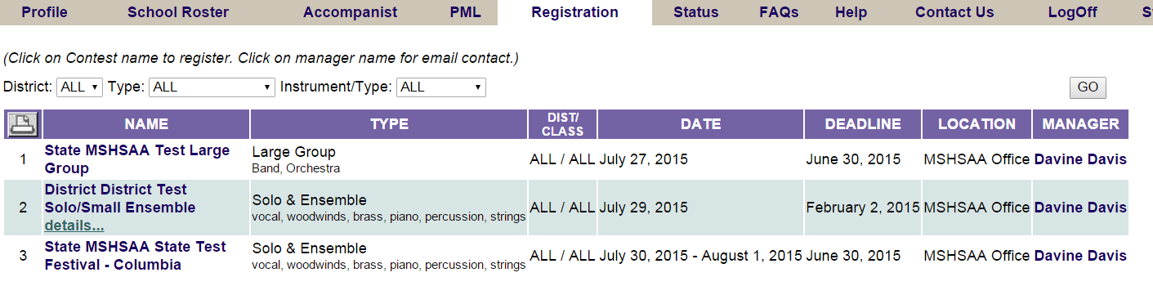

IT IS VERY IMPORTANT THAT SOLOS AND ENSEMBLES USE 2 DIFFERENT ENTRY FORMS; YOU CANNOT ENTER SOLOS AND ENSEMBLES ON THE SAME FORM!!!!

SOLO EVENTS
Once the window opens and you click on the name of the festival, a screen will appear that will show you any existing entry forms you have created for that particular festival site. If you have not created any entry forms for that particular festival, select 'create a new entry form' (green arrow, Figure 7).

A new screen will appear (Figure 8); you must indicate what type of form you are entering (solo or ensemble; blue arrow, Figure 8). The program will default to solo each time. If you teach at more than one school district you will need to select the appropriate school from the drop down box. If you have any special request you will need to enter it in the box called 'Special Request' (green arrow Figure 8). Once you have the correct information listed, click the 'Create' button (red arrow, Figure 8) at the top-right corner. The program will now create an official invoice, with a unique form ID number, select 'OK'. The new form has been created, but is basically 'blank'. It has your school name, your name, as music director, and other information; but no entries appear on this form (Figure 9).

Figure 7
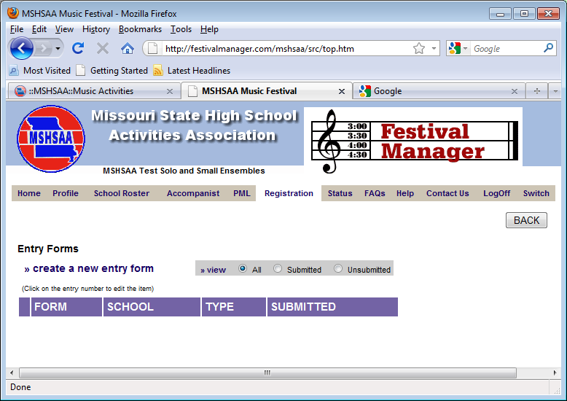
Figure 8
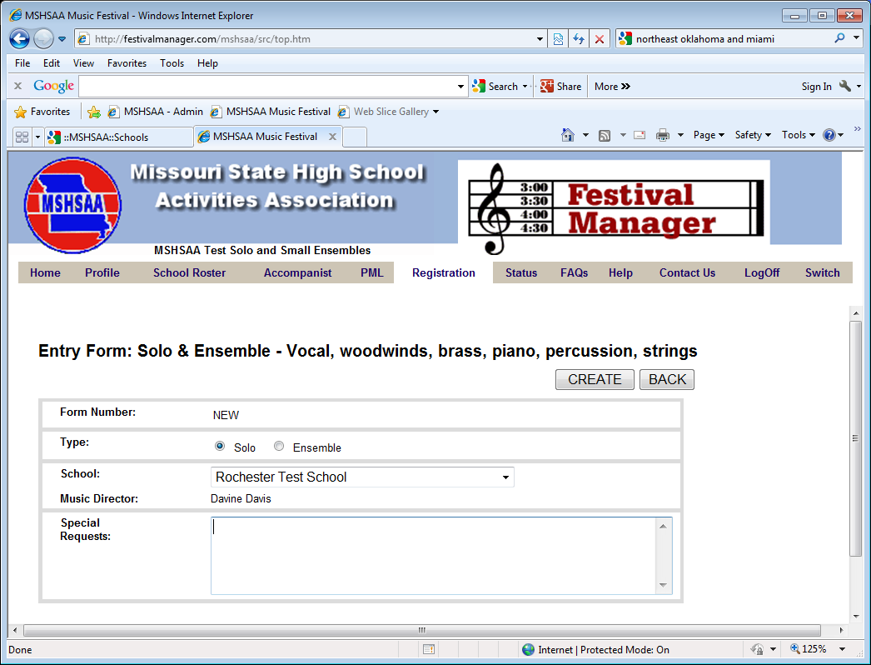

To add a soloist, click 'add soloist’ (purple arrow, Figure 9).

Figure 9
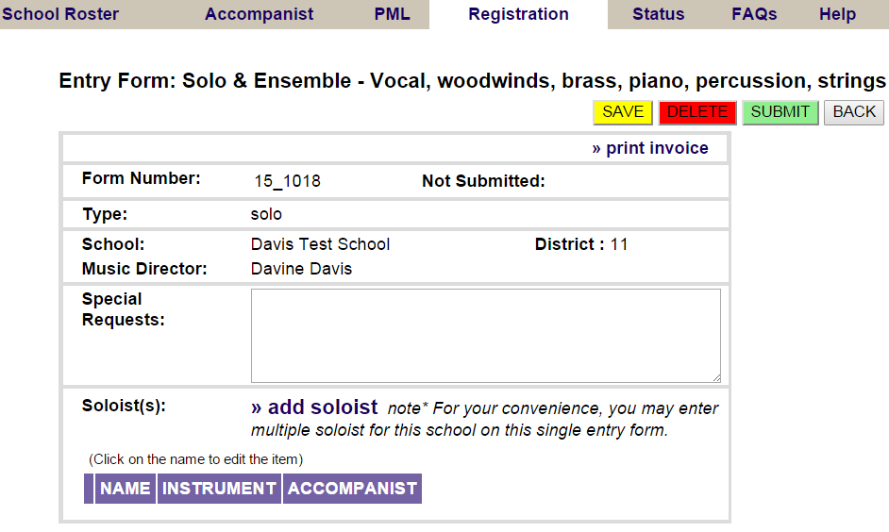

A new screen will appear with the title 'Soloist' (Figure 10). Any field appearing in red is a required field and information must be entered in order to add the event. Using the drop down menu, select the student's name; the name will only appear if you have entered the student on the school roster tab in Festival Manager (Figure 11). You must have the name listed on the ‘School Roster’ and the ‘Accompanist’ in the MSHSAA Festival Manager program prior to entering the solo. Refer to instructions on page 1 and 2. You will click on the 'Instrument' field, and all possible solos for the festival are listed, select the correct solo and list the correct accompanist (if needed) from the pull down menu. The scheduling program will make sure not to schedule your accompanist in more than one location at any single time if this information has been entered correctly.
REMINDER: DO NOT list an accompanist as 'Eagles1' or 'Rushmore HS' (Figure 12). The accompanist will not be able to access their complete schedule if the names do not match and schedule conflicts will occur. Any such entries found on the accompanist list will be deleted immediately.

You are now ready to enter the PML code for your event (Figure 13).

Figure 10
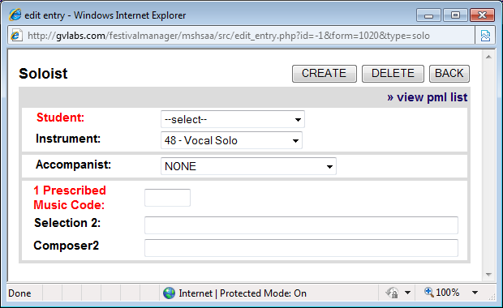

Figure 11
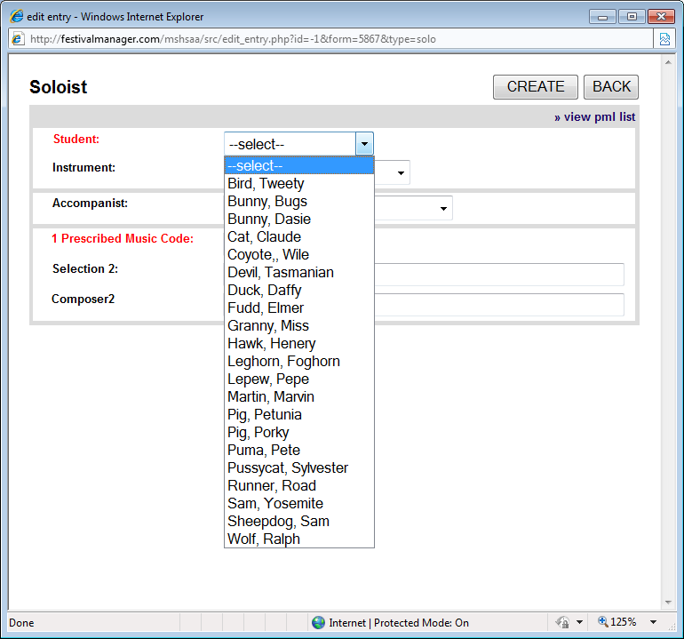

Figure 12
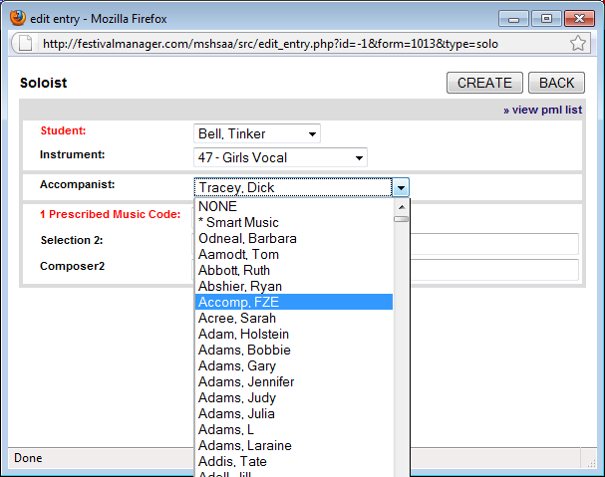

Figure 13
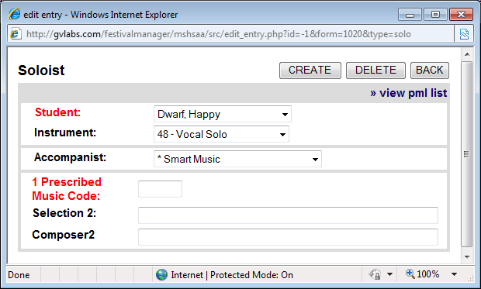

HOW TO ASSIGN A PML CODE TO SOLOS
Instrumental
Each title appearing on the MSHSAA Prescribed Graded Music List (PML) has its own unique number. This number is not reflective of grade level. The list also addresses the 'cross-over' lists (e.g. piccolo solos performing flute literature, baritone solos performing trumpet or trombone literature, etc.). When you view the list you will notice that some lists will include more than one event type. Also if a selection has been listed as being under the 3 minute minimum time requirement a pop-up box will appear after you enter the PML number advising you of this. If you do not enter an additional selection from the PML you are acknowledging that the performance will be automatically lowered one rank. You may also access the PML by selecting 'view pml list' located in the top left-hand corner of the screen.

You do not have to list the name of the required piece, just the pml number. Once you have entered the number click the mouse on any area of the box and the title should appear beside the number. If a second selection is required you can enter the pml number in the Selection 2 box (Figure 14). Once the information appears correctly select 'Create' (red arrow, Figure 14) and 'OK'. Another window will appear summarizing the information you have entered if any of the information is incorrect you may change it. Remember to select 'Update' to save any changes (blue arrow, Figure 15). If no changes are necessary, click on the 'Back' button to add the soloist (green arrow, Figure 15). The soloist should appear at the bottom of the entry form page (Figure 16). You can enter as many soloists as you wish on this form by repeating the process.

NOTE: DO NOT CREATE A SEPARATE ENTRY FORM FOR EACH SOLO EVENT.

Figure 14
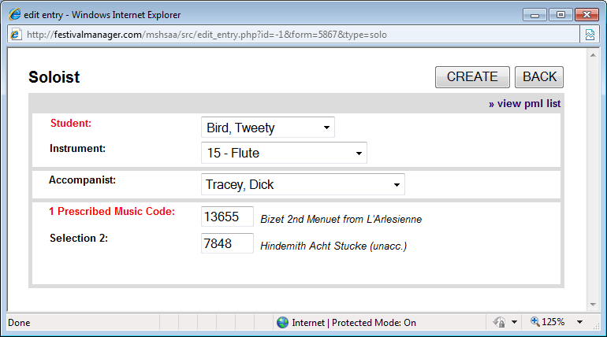

Figure 15
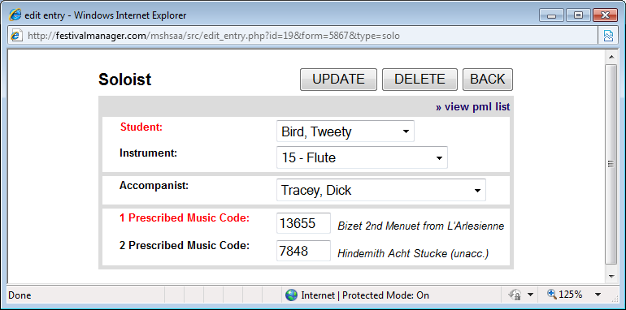

Figure 16
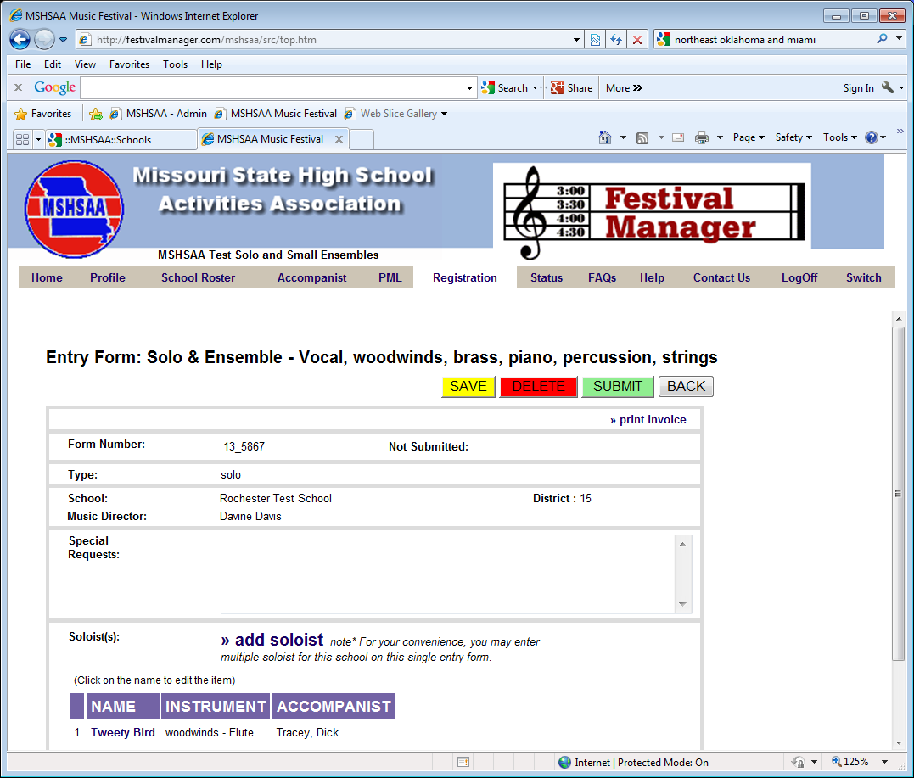

Vocal
Vocalist must perform two selections with at least one selection from the MSHSAA Prescribed Graded Music List. The PML is on-line, under the 'PML' button (just to the left of 'Registration') as well as a separate link under the music activities page of the MSHSAA website. You may also access the PML by selecting 'view pml list' located in the top right-hand corner of the screen. You will use the same instructions as the instrumental solo when entering the pml number(s). For vocalist, the second selection does not have to come from the PML, so you are required to enter the actual name and composer/arranger of your second selection (Figure 17). This information will appear on the adjudication form.

After filling in all of your selections, select the 'Create' button in the top right-hand corner. You will see the message 'Soloist added'; select 'OK', then 'Back' (Figure 18). You will now see that the soloist has been added to your entry form at the bottom (Figure 19). You can list as many soloists as you wish on this one form, simply repeat the process.

NOTE: DO NOT CREATE A NEW ENTRY FORM FOR EACH SOLOIST.

Figure 17
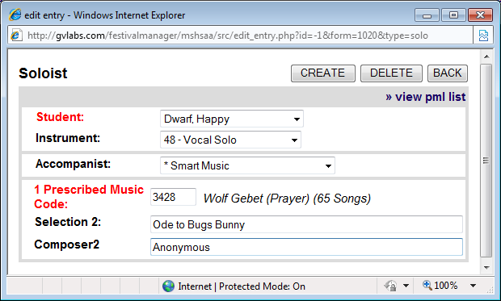

Figure 18
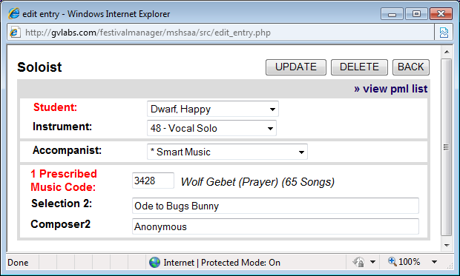

Figure 19
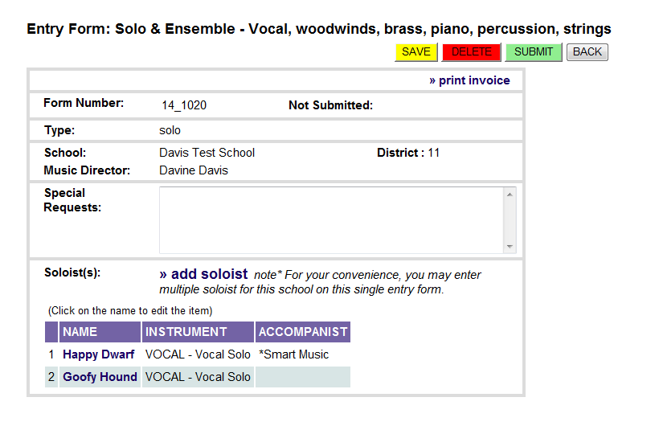

ENSEMBLE EVENTS

Ensembles are very similar to the solo events, but they must be listed on a separate ensemble form. Refer to the directions in the section ‘How to Enter a Solo or Small Ensemble’, located on page 4 and instead of selecting the solo button select the ‘ensemble’ button (Figure 20).
IT IS VERY IMPORTANT THAT SOLOS AND ENSEMBLES USE 2 DIFFERENT ENTRY FORMS; YOU CANNOT ENTER SOLOS AND ENSEMBLES ON THE SAME FORM!

Figure 20
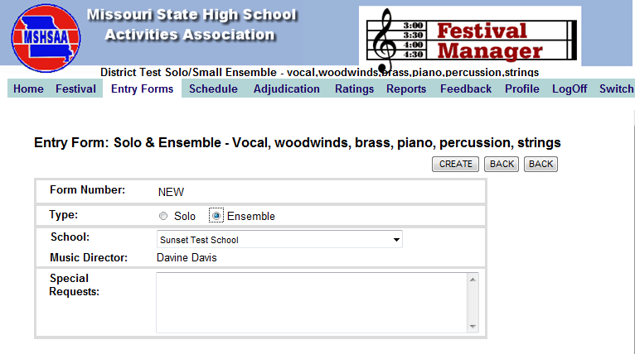
The program has now created an official entry form, with a unique form ID number (Figure 21). The new form has been created, but is basically 'blank'. It has your school name, your name and other information; but no ensembles appear on this entry. To add an ensemble, simply click 'add ensemble'. This process will be very similar to the solo event but there are minor differences that are explained below.

Figure 21
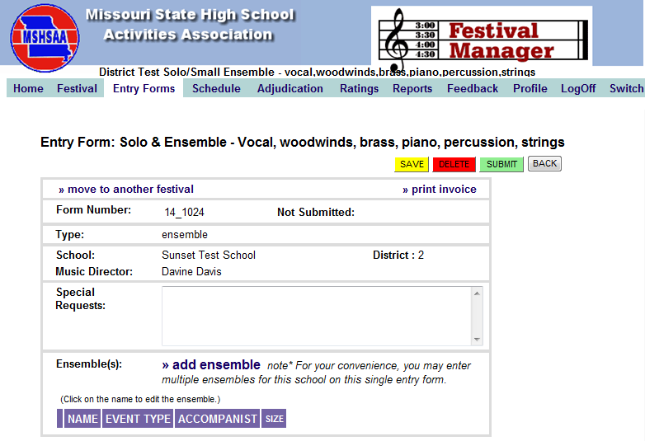
A new screen will appear with the title 'ensemble'. You will have to provide a unique/different name for each ensemble, such as 'Smith Quartet' or 'Davis Girls 3'. DO NOT name all your ensembles the same (i.e. string duet or girls trio). Try to use one name out of the ensemble to help you remember who is in the event (i.e. Jones Perc. Ensemble or Miller Mixed 4). Please note this information will appear on the MSHSAA website so choose appropriate names for your events.

On the instrument line, simply choose the correct ensemble from the pull-down menu, and also provide the correct name of your accompanist. If the accompanist's name is not listed, you will need to add them by selecting the 'Accompanist' button located on the gray toolbar. Refer to information on page 1 regarding accompanist name.

HOW TO ASSIGN A PML CODE TO ENSEMBLE EVENTS

Next enter in the prescribed music number using the same steps outlined for a solo event. Once you have this information entered select the 'Create' button at the top-right. You will see the message 'Ensemble added', hit 'OK'.

You will see that a number of pull-down menus appear below the purple bar titled ‘Member Name’, asking for the students names who are going to be in this ensemble (Figure 22). The names will only appear if they are on your ‘school roster’; you must have the name listed prior to entering the ensemble. The scheduling program will make sure not to schedule any member of the ensemble in more than one location at any single time. For percussion ensemble events you may have to add additional members to the ensemble as the program defaults to the minimum of 3. To do this select the ‘add a member’ link until you have the correct number required for the selection (red arrow, Figure 22). You will select the name by clicking on the drop down box (green arrow, Figure 23). After you have completed all information, select the 'update' (blue arrow, Figure 24) button in the top-right corner, then 'OK' and 'Back' buttons (green arrow, Figure 24). You will be taken back to your ensemble form. You will now see that the ensemble is added to your entry form at the bottom (purple arrow, Figure 25).
Reminder: For miscellaneous and percussion ensembles the number of individuals will default to 3. If the ensemble has more than 3 members you will need to click the ‘add a member’ link until you reach the correct number for the ensemble.

Figure 22
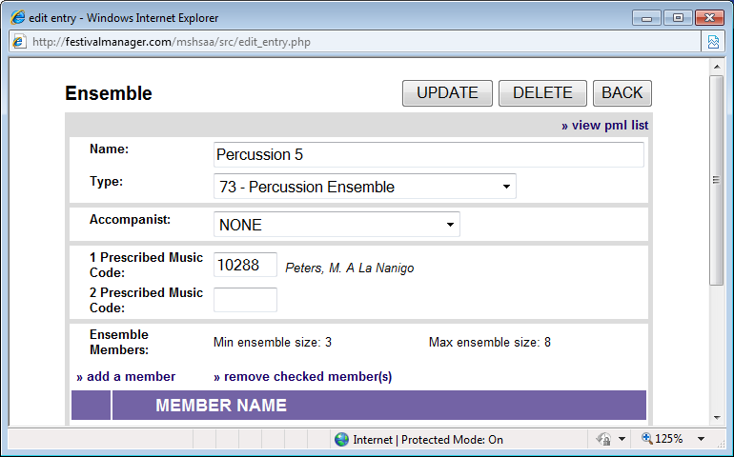

Figure 23
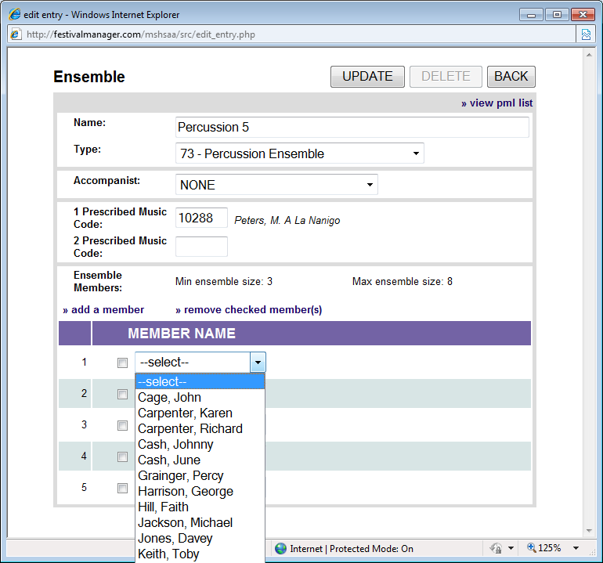

Figure 24
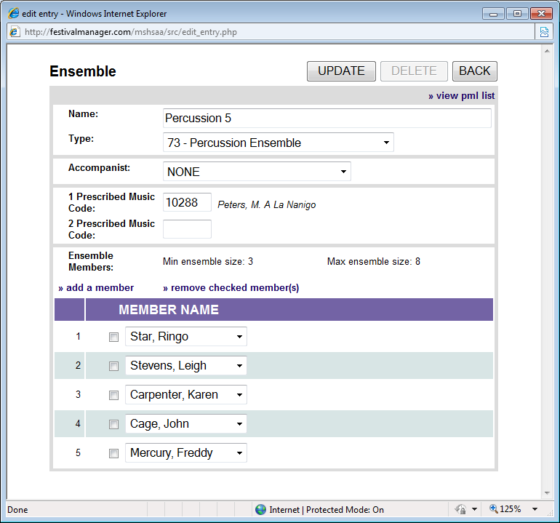

Figure 25
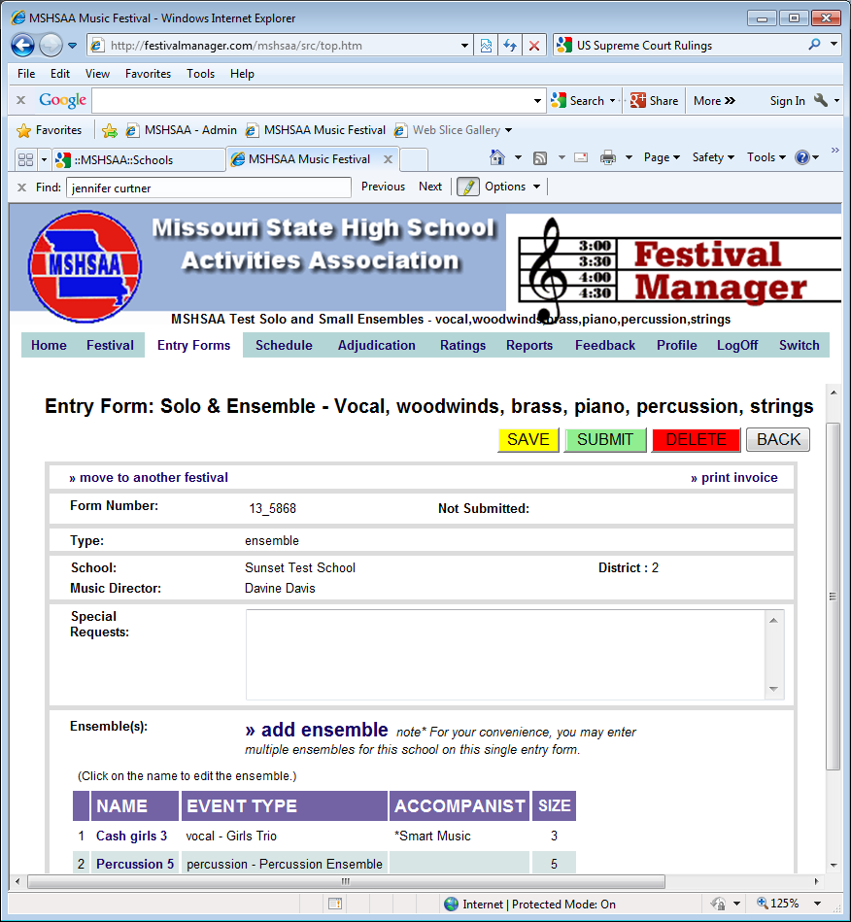

You can list as many ensembles, as allowed per MSHSAA Festival Rules, on this one form, simply repeat the process. You may also remove members as well by checking on box beside the name and selecting 'remove checked member(s)'.

Figure 26
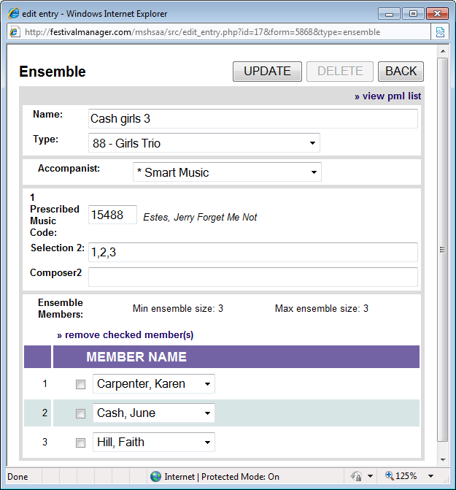

Select the 'SAVE' (yellow) button before you log-off the program to save your entry form (Figure 27).

Figure 27
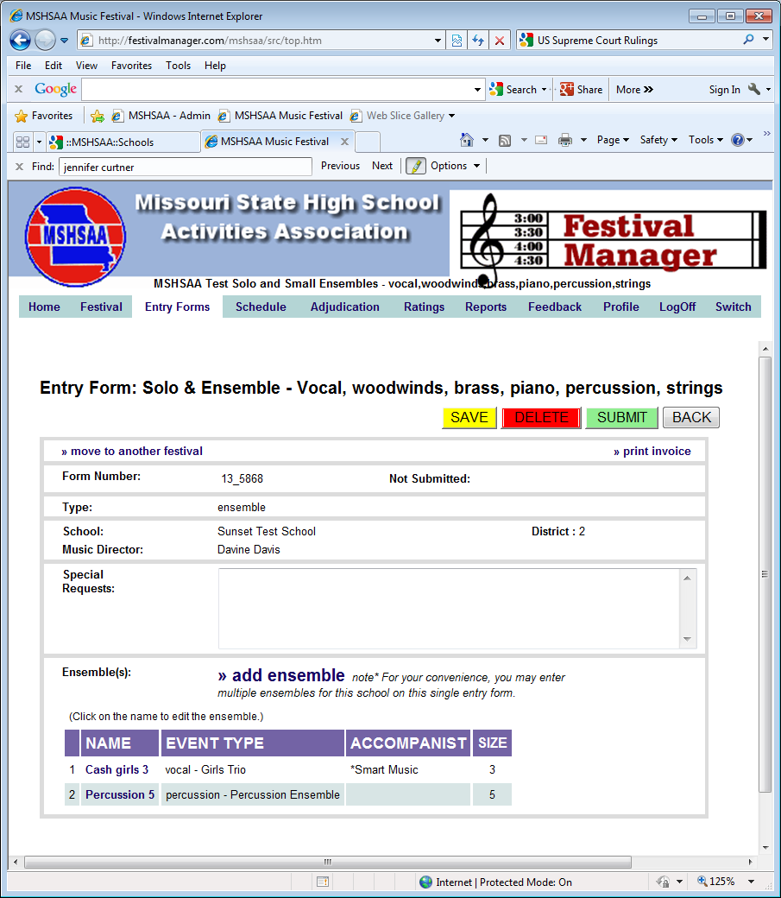

HOW to SUBMIT ENTRY FORMS
Notice that even though you have filled out the forms, and added groups, you have NOT electronically 'Submitted' the form to MSHSSA or to the festival manager (red arrow, Figure 28). At some point when you are confident that you have finished adding events to the form(s), open the form and select the 'SUBMIT' button (green arrow, Figure 28). A pop-up window will appear prompting you to print a copy of this invoice (Figure 29). Select 'OK'. Another screen will appear. This is your invoice and entry form (Figure 30). Please notice it will show the exact time and date that you submitted the form (red arrow, Figure 30). Select the 'print' button to generate a copy of your entries. This invoice serves as proof of your submitted entries and will also be needed to generate the payment process.

You must print off a copy of your invoice(s) and forward to your accounting office for payment to MSHSAA.

NOTE: Selection information should appear on the invoice in ( ) under the ‘Category’ column for each event entered (pink arrow, Figure 30). This will allow your students to double check their selections to ensure that the correct titles have been entered.

Figure 28

Figure 29
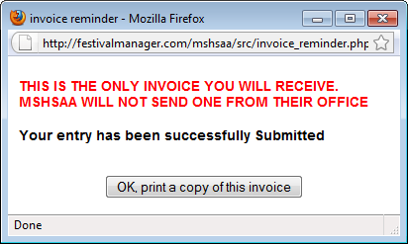

Figure 30
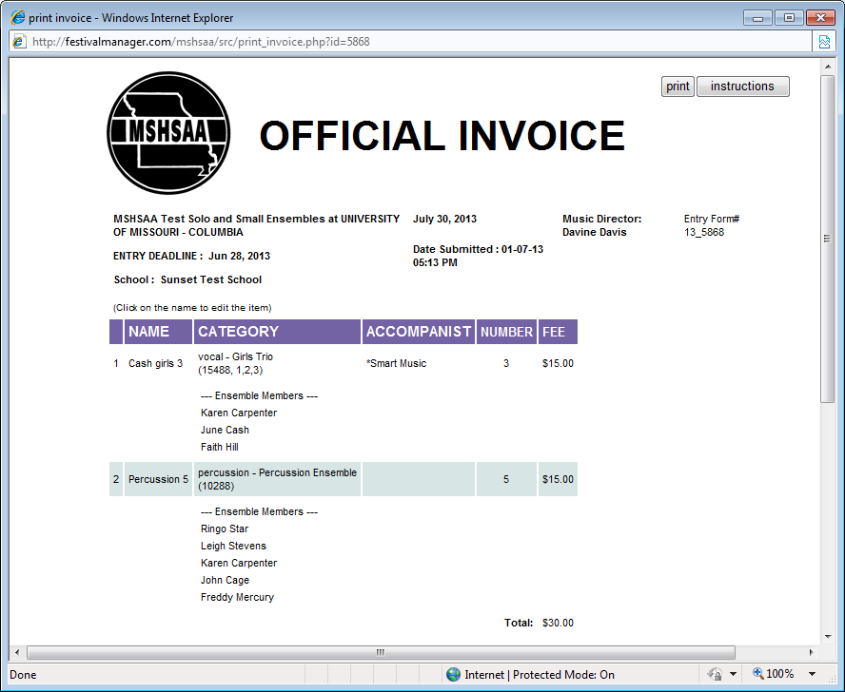

FINAL REMINDERS

A copy of the invoice(s), should be printed and forwarded to your accounting office for payment to MSHSAA. The MSHSAA address will appear on the invoice. That is all you have to do. By clicking the 'Status' button at the top of the screen, on the gray toolbar you will see the status of your entry forms. It will show if your forms are 'Not Submitted', ‘Waiting to Be Scheduled' or 'Scheduled' (yellow arrow, Figure 31). Once the entry deadline has passed you will no longer have access to your entry forms. If you need to print or view this information you may do so under the ‘Status’ link by selecting the red form number located under the ‘form’ column (see blue arrow; Figure 31 ).

Once the manager has completed the scheduling process you will receive an email alert informing you that the schedule is available for viewing. You may view your schedule by selecting the 'status' button. Your schedule will appear at the bottom and all you will need to do is select 'view my schedule’ link
(yellow arrow, Figure 32).

ALL ENTRY FORMS MUST BE SUBMITTED BY 11:00 P.M. ON THE DEADLINE DATED LISTED IN THE MSHSAA FESTIVAL MANAGER PROGRAM AND UNDER THE MUSIC ACTIVITIES LINK OF THE MSHSAA WEBSITE.
NOTE: The time stamp will appear 6 hours ahead of the Central Time Zone as the servers for the Festival Manager program are not located in the Central Time Zone. The program has been set up to adjust for this time change.

Figure 31
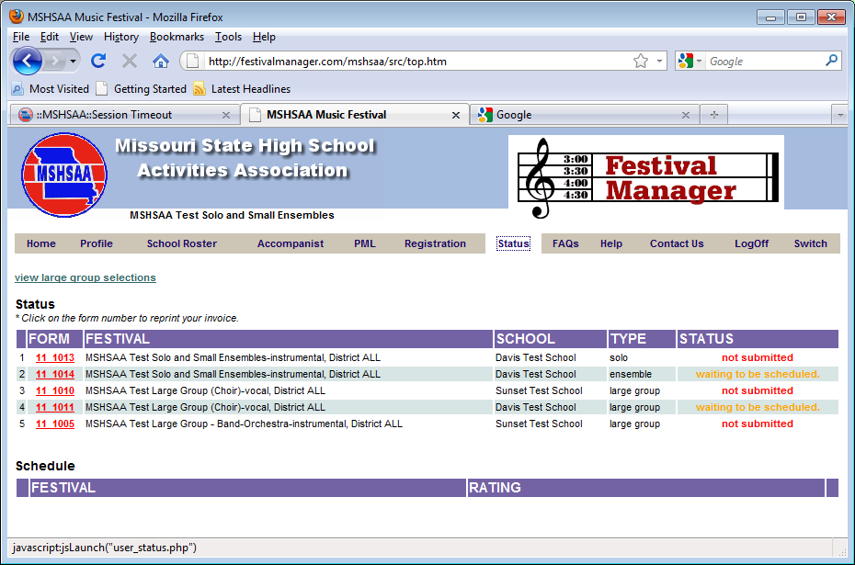

Figure 32
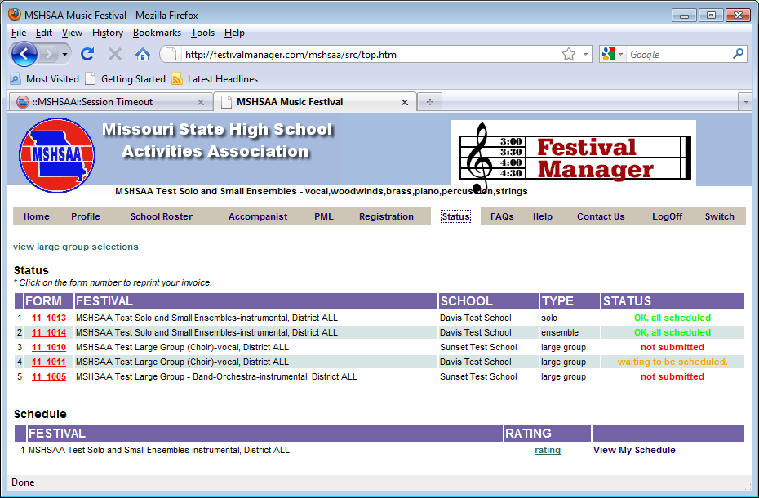

If you have any questions regarding the entry directions, please contact the MSHSAA office at 573-875-4880. Thank you.

MSHSAA
P.O. Box 1328
Columbia, MO 65205-1328

