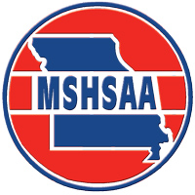

**One-Day Cheer Clinic**

**Request for Refund Form**

Fax: 573-875-1450 Phone: 573-875-4880

Please complete the information below and fax to the MSHSAA Office, Attention: Stacey Slaughter, by **June 15, 2013** in order to receive a refund for the One-Day Cheer Clinics.

* School Name Click here to enter text.
* Address: Click here to enter text.

City Click here to enter text. Zip Click here to enter text.

* Date of Clinic Click here to enter text. Site Click here to enter text.
* Person Requesting Refund: Click here to enter text.
* Position: Click here to enter text.
* Number Pre-Registered: Click here to enter text. Number Attended: Click here to enter text.
* I am requesting: Click here to enter text. refunds at $10.00**\*** per participant for a total of $Click here to enter text.
* Signature: Click here to enter text. Date: Click here to enter text.

(Administrator)

**\*** Refunds will be in the amount of $10.00 per registered participant as the remainder of the fee goes towards the cost associated for the clinic. The t-shirt is yours to keep.

C:\Users\Davine\AppData\Local\Microsoft\Windows\Temporary Internet Files\Content.IE5\XBN5HTI4\MC900305669[1].wmf